SIMATS ENGINEERING (SAVEETHA SCHOOL OF ENGINEERING)

Department of Computer Science and Engineering

ASSESSMENT TOOL 1 – APPLICATION BASED QUESTIONS

Course Code: | CSA0621 | Course Title: | Design and Analysis of Algorithms
CO Assessed: | CO1 – Precision (BL1, BL2, BL3) | Assessment: | Assessment Tool 1 – Application Based Questions
Weightage: | 40% of CIA | Total Marks: | 100 (2 Questions × 50 Marks)
CO1 Statement: | Determine algorithm efficiency using asymptotic notations and mathematical techniques including Master Theorem and substitution method. (BL1, BL2, BL3)
Student Name: | A M RAKESH | Reg. No.: | 192424393
Section / Batch: | CSE – AI & DS - 3 YEAR | Date: | 21-7-2026
Instructions to Students
- Answer BOTH questions. Each question carries 50 Marks. Total: 100 Marks.
- Clearly show all steps in derivations and complexity analysis.
- Use proper asymptotic notation (Big-O, Big-Θ, Big-Ω) wherever required.
- Justify each step in recurrence solving using appropriate methods.
- Neat presentation and logical explanation are mandatory

Question Type | Focus Area | Questions | Marks
Application-Based Questions | Apply Master Theorem and asymptotic analysis to real-world scenarios | Q1 – Q2 | Q1 –50  Q2 –50
GRAND TOTAL: |  | 100 Marks

SECTION A – APPLICATION BASED QUESTIONS

Q1. Application: Weather Forecasting Simulation System
A weather simulation system uses two algorithms with complexities O(n log n) and O(n² log n). Analyze both algorithms using asymptotic notation and compare their growth rates. Explain how each algorithm performs as the dataset size increases. Determine which algorithm is more efficient for large-scale simulations. Justify your answer based on computational efficiency and scalability.

Q2. Application: Online Learning Recommendation System
An online learning platform processes user interaction data using the recurrence T(n) = T(n−1)
+ n. Apply the substitution method to expand the recurrence step-by-step and derive the final time complexity. Clearly show intermediate steps and simplify the expression. Analyze how the algorithm performs when the number of users grows rapidly. Interpret the efficiency using asymptotic notation and discuss whether the system is scalable for large educational platforms.

Q1. Application: Weather Forecasting Simulation System
- Understanding of Problem Context
A weather forecasting simulation system processes a large amount of data such as temperature, humidity, wind speed, pressure, and historical weather records. The efficiency of the algorithms is important because the dataset size can become very large.
The two algorithms have the following time complexities:
  - Algorithm 1: 𝑂(𝑛 log 𝑙𝑜𝑔 𝑛 )

  - Algorithm 2: 𝑂(𝑛2 log 𝑙𝑜𝑔 𝑛 )
Here, n represents the size of the weather dataset.
- Application of Concepts Algorithm 1: 𝑂(𝑛 log 𝑙𝑜𝑔 𝑛 )
This algorithm performs a linear amount of work 𝑛combined with a logarithmic factor log 𝑙𝑜𝑔 𝑛 . Example:
𝑇 (𝑛) = 𝑛 log 𝑙𝑜𝑔 𝑛
1
Its growth is relatively slow. When the dataset size increases, the execution time increases efficiently.
Algorithm 2: 𝑂(𝑛2 log 𝑙𝑜𝑔 𝑛 )
This algorithm contains a quadratic term 𝑛2along with log 𝑙𝑜𝑔 𝑛 .

2
𝑇 (𝑛) = 𝑛
2
log 𝑙𝑜𝑔 𝑛

The 2term causes the execution time to increase very rapidly as the dataset becomes larger.
𝑛

Problem-Solving Approach
To compare both algorithms:

Cancelling the common terms:
𝑂(𝑛 log𝑙𝑜𝑔 𝑛 )
𝑂(𝑛log𝑙𝑜𝑔 𝑛 )
2

2
= 𝑛 log𝑙𝑜𝑔 𝑛 = 𝑛

𝑛log𝑙𝑜𝑔 𝑛
Therefore, Algorithm 2 is approximately n times slower than Algorithm 1 for the same dataset size.

Dataset Size | 𝑂(𝑛 log 𝑙𝑜𝑔 𝑛 ) | 2  𝑂(𝑛 log 𝑙𝑜𝑔
Small | Efficient | Acceptable
Medium | Efficient | Slower
Large | Highly efficient | Very slow
Very Large | Suitable | Impractical
For example, when 𝑛increases from 1,000 to 10,000, the 2component in Algorithm 2 increases significantly, causing a much greater increase in computational time.
𝑛

Accuracy of Solution and Comparison
The growth rates are:
𝑂(𝑛 log 𝑙𝑜𝑔 𝑛 ) < 𝑂(𝑛2 log 𝑙𝑜𝑔 𝑛 )

The 𝑂(𝑛 log 𝑙𝑜𝑔 𝑛 )algorithm has a lower asymptotic growth rate. It uses computational resources more efficiently and can process large weather datasets faster.
The 𝑂(𝑛2 log 𝑙𝑜𝑔 𝑛 )algorithm may be useful for small datasets or when complex pairwise comparisons are
required. However, its performance decreases rapidly when the number of weather records increases.

Conclusion
The 𝑂(𝑛 log 𝑙𝑜𝑔 𝑛 )algorithm is more efficient for large-scale weather forecasting simulations.
Although both algorithms contain the logarithmic factor log 𝑙𝑜𝑔 𝑛 , the second algorithm has an additional 2factor. Therefore:
𝑛
𝑂(𝑛 log 𝑙𝑜𝑔 𝑛 ) 𝑖𝑠 𝑚𝑜𝑟𝑒 𝑒𝑓𝑓𝑖𝑐𝑖𝑒𝑛𝑡 𝑡ℎ𝑎𝑛 𝑂(𝑛 log 𝑙𝑜𝑔 𝑛 )
2
For large weather datasets, the 𝑂(𝑛 log 𝑙𝑜𝑔 𝑛 )algorithm is preferred because it has a slower growth rate, requires
less computational time, and scales better as the dataset size increases. The 𝑂(𝑛2 log 𝑙𝑜𝑔 𝑛 )algorithm becomes increasingly expensive and may not be suitable for real-time or large-scale weather simulations.

Code
import java.util.Arrays;

public class WeatherForecasting { public static void main(String[] args) {
int n = 1000;
int[] weatherData = new int[n];

// Generate weather data for (int i = 0; i < n; i++) {
weatherData[i] = (int)(Math.random() * 100);
}

// Algorithm 1: O(n log n)
long start1 = System.nanoTime(); Arrays.sort(weatherData);
long end1 = System.nanoTime();

// Algorithm 2: O(n² log n)
long start2 = System.nanoTime();

for (int i = 0; i < n; i++) { for (int j = 0; j < n; j++) {
for (int k = 1; k < n; k = k * 2) { int x = i + j + k;
}
}
}
long end2 = System.nanoTime(); System.out.println("Weather Dataset Size: " + n); System.out.println("O(n log n) Time: "
+ (end1 - start1) + " nanoseconds");

System.out.println("O(n² log n) Time: "
+ (end2 - start2) + " nanoseconds");

System.out.println("\nConclusion:");
System.out.println("O(n log n) is more efficient for large-scale simulations.");
}
}

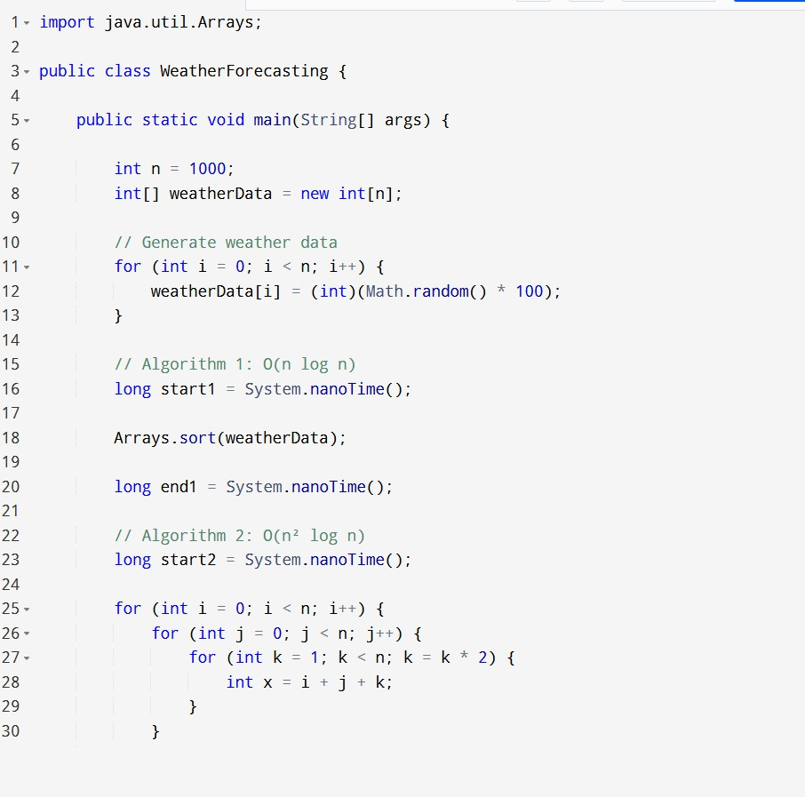
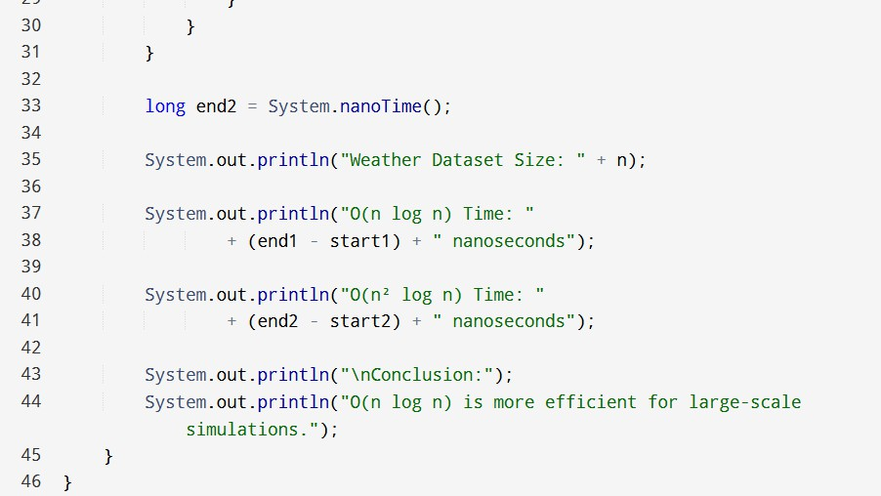
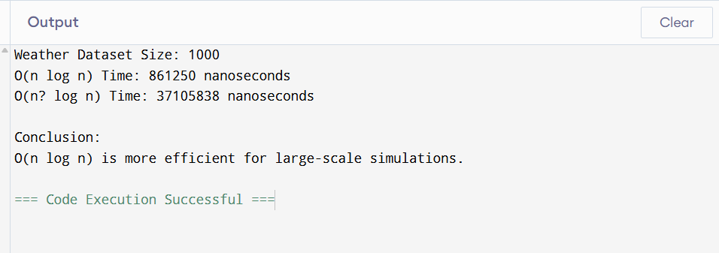

Q2. Application: Online Learning Recommendation System
- Understanding of Problem Context
An online learning platform collects user interaction data such as:
  - Courses viewed

  - Videos watched

  - Quiz attempts

  - Search history

  - Course ratings

Suppose the recommendation algorithm follows the recurrence:
𝑇(𝑛) = 𝑇(𝑛 − 1) + 𝑛
where n represents the number of users or interaction records being processed.

Application of Substitution Method
Given:
𝑇(𝑛) = 𝑇(𝑛 − 1) + 𝑛
Step 1: Expand 𝑇(𝑛 − 1)
𝑇(𝑛) = [𝑇(𝑛 − 2) + (𝑛 − 1)] + 𝑛𝑇(𝑛) = 𝑇(𝑛 − 2) + (𝑛 − 1) + 𝑛
Step 2: Expand 𝑇(𝑛 − 2)
𝑇(𝑛) = [𝑇(𝑛 − 3) + (𝑛 − 2)] + (𝑛 − 1) + 𝑛𝑇(𝑛) = 𝑇(𝑛 − 3) + (𝑛 − 2) + (𝑛 − 1) + 𝑛

Step 3: Continue Expansion

When 𝑘 = 𝑛:
𝑇(𝑛) = 𝑇(𝑛 − 𝑘) + (𝑛 − 𝑘 + 1) + ⋯ + (𝑛 − 1) + 𝑛

𝑇(𝑛) = 𝑇(0) + 1 + 2 + 3 + ⋯ + 𝑛

The sum of the first 𝑛natural numbers is:
1 + 2 + 3 + ⋯ + 𝑛 = ^{𝑛(𝑛+1)}
2
Therefore:
𝑇(𝑛) = 𝑇(0) + ^{𝑛(𝑛+1)}
2
Ignoring the constant 𝑇(0):

2
𝑇(𝑛) = ^{𝑛} ^{+𝑛}

2
The dominant term is: 𝑇(𝑛) = 𝑂(𝑛2)

Problem-Solving Approach
The recurrence adds a new amount of work at every step:
1 + 2 + 3 + ⋯ + 𝑛
This creates a quadratic growth pattern. For example:
Number of Users 𝑛 | Approximate Work
10 | 55

Number of Users 𝑛 | Approximate Work
100 | 5,050
1,000 | 500,500
10,000 | 50,005,000
When the number of users increases, the computational work increases approximately as the square of the number of users.

Accuracy of Solution and Scalability
The final complexity is:

This means that if the number of users doubles:
𝑂(𝑛 )

𝑇(2𝑛)≈4𝑇(𝑛)
2

Therefore, the algorithm becomes significantly slower as the number of users increases.
For a small online learning platform, this algorithm may work effectively. However, for large educational platforms
with millions of users, an 𝑂(𝑛2)algorithm is generally not scalable. More efficient algorithms such as:
𝑂(𝑛), 𝑂(𝑛 log 𝑙𝑜𝑔 𝑛 )
would be preferred for large-scale recommendation systems.

Conclusion
Using the substitution method:

expands to:

𝑇(𝑛) = 𝑇(𝑛 − 1) + 𝑛

𝑇(𝑛) = 𝑇(0) + 1 + 2 + 3 + ⋯ + 𝑛𝑇(𝑛) = 𝑇(0) + ^{𝑛(𝑛+1)}
2
Therefore:
𝑇(𝑛) = Θ(𝑛 )
2
The algorithm has quadratic time complexity. As the number of users grows rapidly, the processing time
increases very quickly. Hence, this algorithm is not highly scalable for large educational platforms, and a more efficient algorithm with 𝑂(𝑛)or 𝑂(𝑛 log 𝑙𝑜𝑔 𝑛 )complexity would be better.

Code
import java.util.Scanner;

public class OnlineLearningRecommendation { public static void main(String[] args) {
Scanner sc = new Scanner(System.in);

System.out.print("Enter number of users: "); int n = sc.nextInt();

long totalWork = 0;

// T(n) = T(n-1) + n
for (int i = 1; i <= n; i++) { totalWork = totalWork + i;
}

System.out.println("\nNumber of Users: " + n); System.out.println("Total Work: " + totalWork);

System.out.println("Time Complexity: O(n^2)");
System.out.println("Conclusion: The algorithm becomes slower as users increase.");
}
}
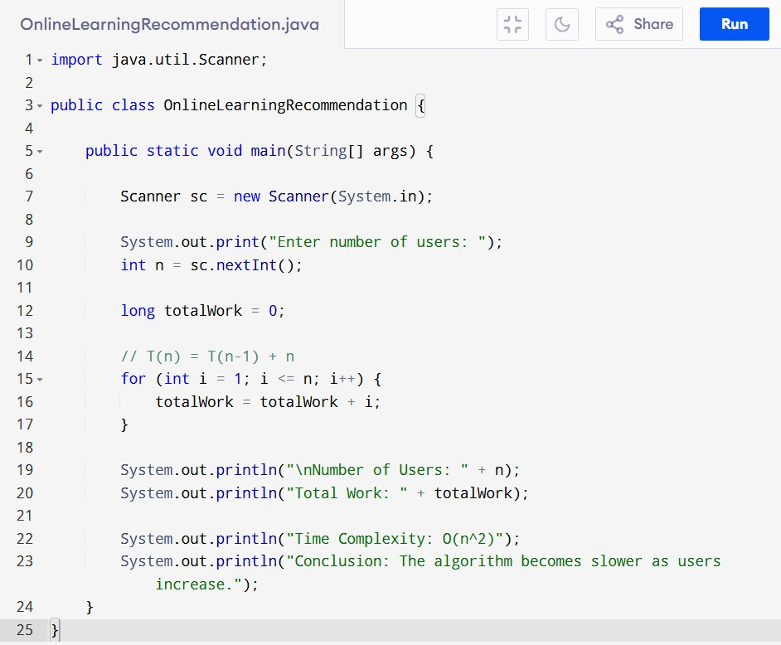

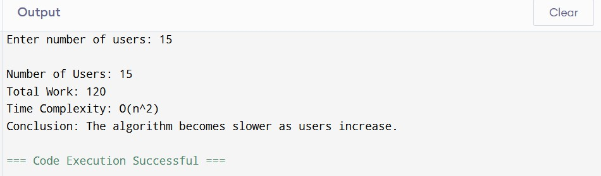


Code of Conduct AMRAKESHcertify that this submission is my original work and that I have adhered to the guidelines specified for this assessment. I understand that any violation of academic integrity rules will result in disciplinary action.

Signature of the Student:

RUBRICS FOR CALCULATION

Criteria | Wt. | Level 4 – Exemplary | Level 3 – Proficient | Level 2 – Developing | Level 1 – Beginning
Understanding of Problem Context | 20% | Clearly understands the problem and accurately identifies all requirements | Good understanding with minor gaps | Basic understanding; some requirements unclear | Poor understanding or misinterpretation of the problem
Application of Concepts | 30% | Accurately applies appropriate concepts to solve complex problems | Applies relevant concepts correctly with minor errors | Applies basic concepts with limited accuracy | Fails to apply appropriate concepts
Problem-Solvi ng Approach | 20% | Logical, well-structured, and efficient approach | Mostly logical approach with minor gaps | Basic approach with some inconsistencies | Illogical or unclear approach

Accuracy of Solution | 20% | Completely correct solution with proper justification | Mostly correct with minor errors | Partially correct solution | Incorrect or incomplete solution
Clarity | 10% | Clear, well-organized, and properly explained solution | Understandable with minor clarity issues | Limited clarity and explanation | Poorly presented and difficult to understand

Marks Evaluation:
Question No. | Understanding of Problem Context (20%) | Application of Concepts (30%) | Problem-So lving Approach (20%) | Accuracy of Solution (20%) | Clarity (10%) | Total Marks
Q1
(50 Marks)
Q2
(50 Marks)
Overall Total (100)

Faculty In-charge | Course Coordinator | Head of Department
Signature: | Signature: | Signature:
Date: 21 – 7 -2026 | Date: 21 – 7 -2026 | Date: 21 – 7 -2026

